IOCCG Report

Uncertainties in Ocean Colour Remote Sensing

Contents
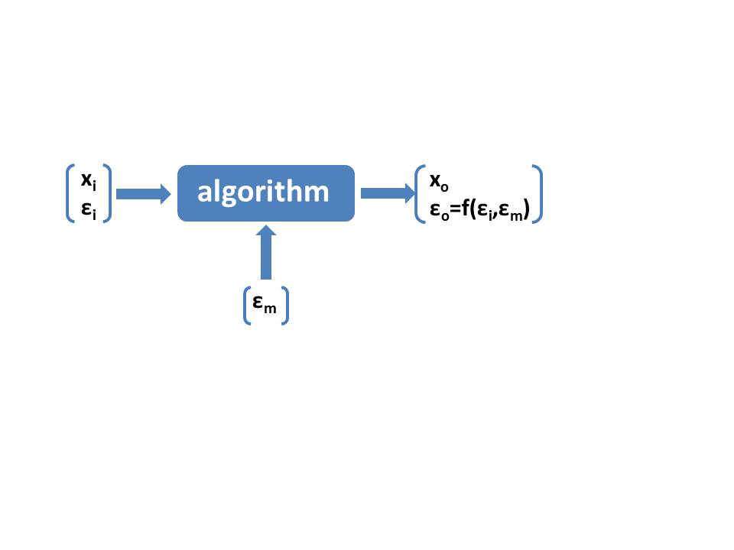

Introduction

As it is the case for any observational data in geo-sciences, also ocean colour remote sensing (OCRS) products are affected by uncertainties, such as the concentration of chlorophyll and suspended matter or the irradiance attenuation coefficient, kd. These uncertainties have to be known when using the data for research or environmental monitoring. Also, the quality of OCRS data, which are indirectly derived from top of atmosphere radiance spectra, is not constant over a scene or a time series, but depends on a multitude of varying factors, which may vary from area to area or with time. Examples are the radiometric properties and stability of the sensor, gases and aerosols in the atmosphere, wind and waves, the optical properties or the vertical distribution of water constituents. Furthermore, conditions may exist in atmosphere or water, for which an algorithm, which is used to determine a property or concentration, has not been designed for. These conditions may lead to spectra which are out of scope of the algorithm. Examples are contrails in the atmosphere, cloud shadows, terrestrial aerosols like dust or smoke, exceptional plankton blooms such as red tides, strong wind with white caps, shallow water with bottom reflection or very high concentrations of water constituents. In such cases the products may be totally wrong, show artefacts and structures in the water, which are effects of the atmosphere, and may mislead the interpretation or further use in numerical models or environmental and climate studies. Finally, it depends then on the application if the quality of a pixel is acceptable.
Remote sensing data are always qualified and validated against in situ observations, which are treated as truth. But also these measurements have their own problems and uncertainties, which depend on the complexity of the method, the conditions, under which the measurements were carried out, and also on strict adhearance to field measurement protocols and community-certified methods for field data processing and uncertainty reporting. But even with a perfect measurement the spatial and temporal differences between in situ and OCR observations must lead to uncertainties when the in situ data are used as the true reference.
Beside these types of errors and uncertainties, also the nature of OCRS with respect to spatial and temporal resolution, captured water volume and depth, limitation by cloud coverage and thus the cloud climate lead to gaps and uncertainties, when synoptic maps and time series are produced and used for analysing changes in the ocean and coastal zones on various spatial and temporal scales.
For a proper use of OCRS data it is necessary to be aware of these potential problems and uncertainties. Since up to now, space agencies provided most OCRS products without estimates of uncertainties, it is necessary to discuss and establish procedures to include this information in the products so that the user of the data can decide by his requirements, which data are acceptable for him.
In this report the IOCCG working group on uncertainties in ocean colour remote sensing summarizes related facts and the results, conclusions and recommendations of discussions in the group and with further experts.

Sources of Uncertainties

Introduce conceptual framework for sources of uncertainties, distinguishing between uncertainties due input data (both TOA and ancillary) and those due to models and algorithms, e.g.:
Optical remote sensing of water properties and water constituents is a complex method. Before achieving the final product of interest it includes a series of intermediate steps, each of which associated with uncertainties. One has to deal with a large and variable number of different factors, which determine the radiance spectrum at top of atmosphere (TOA), from which we derive our information about phytoplankton in the sea, the penetration depth of light, the concentration of suspended matter and even primary production.
Here include a figure: cartoon, which shows the most important natural sources of variability / Uncertainties

On the other hand, the information content of a radiance spectrum at TOA is rather limited and in most cases much smaller than the number of factors, which determine it. To illustrate this problem Fig. xx shows the variability of TOA radiance spectra of the North Sea captured by MERIS, which represents a large variety of optical water types. Listed are potential factors, which might have an impact on the reflectance spectra and which have to be corrected for, even if only one component is of interest, e.g. the phytoplankton chlorophyll concentration. But even then, the optical properties of phytoplankton - for which chlorophyll is used as a measure - can be variable and determine the uncertainty range of the retrieval.
In this chapter we will present and discuss our present knowledge about sources of uncertainties.

Figure 2: Factors, which determine the top of atmosphere radiance spectrum

Comment EKw: Additional parameters for Figure 1: straylight from clouds, land and other bright targets (adjacency effect); atmospheric gases, including anthropogenic gas emissions; cloud shadows

Uncertainties of Input Data
TOA Data

[EKw+MW+RD]
Starting point for all ocean colour products are the top of atmosphere radiance (TOA) spectra. This requires a well calibrated sensor with a high radiometric sensitivity, a high signal to noise ratio (SNR) and a long term stability (IOCCG Report 13, 2012). Furthermore, all of its radiometric and spectral properties must be well characterized pre-launch and on-orbit: sensor absolute and relative radiometric calibration, sensor spectral response function, dark current, radiometric angular dependency, linearity, sensitivity for polarized light and straylight, temperature dependence, etc. These properties have to be monitored during the life time of the sensor. Any deviations must be compensated by correction procedures, because small uncertainties in the order of a few percent in TOA radiances may lead to large errors in the derived water leaving radiances. The remaining uncertainty has to be quantified and included in the overall uncertainty budget.
Specify present knowledge about calibration method (brief), radiometric and spectral accuracy, stability, signal/noise, known issues etc.
Comment JW: Additional sources that are implied but not listed (in case you want to list them): solar and lunar temporal calibrations, detector-to-detector differences, relative spectral responses, vicarious calibration (in situ + methodology)

Ancillary Data

[BF+]
For the evaluation of OC observations ancillary data are necessary, in particular for the correction of the influence of the atmosphere. Depending on the mission, these data, such as ozone, pressure, wind speed, water vapour, NO2, come from the re-analysis of weather forecast data, from other satellite missions, or from a climatology of these variables. In any case all of them have their own uncertainties and, thus, have an impact the accuracy of the OC data.

Material from OBPG & CCI

Uncertainties associated with Models and Algorithms

Atmosphere

[RD+MW+BF]
The atmosphere is one of the major sources for uncertainty. Since over Case 1 waters more than 90% of the measured upward directed radiance in the visible spectral range at TOA is light, which is scattered by the atmosphere (by molecules and aerosols), any error in the determination of the atmospheric path radiance and transmittance leads to a multiple error in the determination of the water leaving radiance. Thus, the so called atmospheric correction is a key to the success of remote sensing. It includes scattering and absorption in the atmosphere as well as the specular reflection at the water surface.
Since the atmosphere, in particular the composition of aerosols and the optical thickness is variable, the uncertainties, which are caused by the atmosphere, may range from low for a clear atmosphere to very high for a turbid atmosphere and up to cases, for which an atmospheric correction with sufficient accuracy is not possible at all, like fog and clouds. Furthermore, the impact of the atmosphere depends on the sun and observation angles (solar and sensor zenith angles). Since scattering by aerosols in forward direction is much larger than into the backward hemisphere, the influence on the TOA radiance changes with the solar-sensor geometry. When viewing into the direction of the sun (despite the sun glint, see below) the sensor receives a much larger radiance scattered by molecules and aerosols. In contrast, the contribution by molecular scattering is relatively lower, due to its different scattering function, i.e., aerosols are strongly forward scattering. Related to this angular problem is the polarisation of radiance in the atmosphere and after it is reflected at the sea surface. In particular for large observation angles, which are close to the Brewster angle, it is important to take polarisation in the atmospheric correction procedure into account.
The importance of the correction of the path radiance increases with decreasing reflectance of the water body. In the clear open ocean the reflectance in the red spectral range is low, due to the high absorption by water. But also the scattering by aerosols and particular by air molecules is also decreasing with increasing wavelength. In contrast, water with high concentrations of humic substances and phytoplankton have a low reflectance in the blue part of the spectrum. Since in this spectral range scattering by molecules in the air and also by many aerosol types is increasing, the ratio of water leaving radiance to the path radiance becomes extremely low and thus the uncertainty of products such as chlorophyll or CDOM may significantly increase up to a level at which the product is not usable.
The reflection by bright targets in the neighbourhood of the water pixels, such as land or clouds, can cause the adjacency effect. It becomes a problem and increases the uncertainty when the light reflected by these bright targets is scattered in the atmosphere again and enters the path in direction to the sensor. This issue is of importance in particular for atmospheric correction procedures, which are based on the determination of the aerosol path radiance from the near infrared (NIR) bands. The high reflection by land vegetation in the NIR can lead to an overestimation of the aerosol path radiance and thus an underestimation of the water reflectance; it may even lead to negative water reflectances.
In addition, cloud shadowing (another type of straylight effect) will caused low sensor-measured TOA radiance, and leading to biased low satellite-derived normalized water-leaving radiance spectra.
Another issue, which causes uncertainties, is the absorption by atmospheric gases, in particular by oxygen, ozone and water vapour, which are the dominating gases with absorption bands in the VIS to NIR spectral range. For most sensors the spectral bands have been placed into regions outside the strong absorption bands of oxygen and water vapour. However, in some of the ocean colour bands there is still some influence of these gases, e.g. in the range > 680 nm. Most atmospheric correction algorithms include procedures to correct this influence, but since they are by far not perfect the gas absorption contributes to the uncertainty budget. The absorption by ozone with its broad absorption band in the VIS range, which covers important ocean colour bands, has to be taken into account in any case. The uncertainty concerning this issue depends on the knowledge of the ozone concentration in the atmosphere at the time and location of observation.

Effects of Clouds, Ice and Land

[RD]
A further source of uncertainty are thin clouds and clouds, which are smaller than the size of the footprint (IFOV, corresponding pixel) of the sensor. While thick and large clouds can easily be detected by simple threshold algorithms and masked out, thin and sub-pixel clouds are in many cases hard to detect if at all. One example are contrails of aircrafts, which - if not properly masked out or corrected - can cause artificial structures in an product such as chlorophyll. Also shadows of clouds and contrails impose problems and artefacts. In many cases they occur as structures of increased chlorophyll concentration in the product.

Sea Surface

[RD]
Since the specular reflectance of direct sun and scattered sky light at the air/sea interface contributes to the path radiance, it has to be included in the atmospheric correction procedure. Problems arise when sun light is directly reflected to the sensor (sun glint). Dependent on the sun and viewing angle and on the wave slope distribution sun glint may exceed by far the normalized water-leaving radiance and atmospheric path radiance. Sun glint is difficult to correct and may lead to large uncertainties or even a loss of half of the image.
Beside the specular reflectance also floating algae, foam and sea ice sheets and cakes can have a significant impact on the determination of the normalized water-leaving radiance. Stormy conditions may cause that a large portion of the ocean surface is covered by white caps. Although in many cases stormy conditions are associated with clouds there are also days with clear sky and strong winds with a high coverage by white caps.
A further limit is set by the sun zenith angle. At low sun elevations some of the problems, which are mentioned above, increase, in particular those associated with the transmittance through the atmosphere, the path radiance and the reflection at the surface.

Optical Properties of Water Constituents

[JW+RD]
The relationship between water constituents and their optical properties is a core problem of establishing a bio-optical model as the basis for developing a retrieval algorithm. In the most simple case we can assume the variability of all water constituents under only one component. Optical water types, for which this simplification is possible, have been denoted by A. Morel as Case 1 water, while all other optical water types, where more than one component is necessary to describe the optical variability, are called Case 2. But even Case 1 water is a mixture of various constituents. The mean composition of phytoplankton pigments determines the absorption spectrum, which can be related to chlorophyll with a certain range of variability, and which determines the uncertainty.
The scatter plot of Fig. xx shows the variability between the absorption coefficient at 443 nm and the chlorophyll concentration for Case 1 water. The data are taken from the NOMAD data set for all samples from locations with a water depth > 100 m to exclude most of the turbid water.

Figure 2: Relationship between chlorophyll concentration and the pigment absorption coefficient of the NOMAD data

The other uncertainty range with respect to chlorophyll is shown (Fig. xx), when plotting the in situ spectral water reflectance ratio rw(443) / rw560) as a function of chlorophyll, which is often used as the empirical algorithm for retrieving chlorophyll of cased 1 water. Also here the scatter is in the order of > 50%.

Figure 2: Relationship between the ratio of the water reflection and 443 and 555 nm and the chlorophyll concentration

In optically complex water with many different water constituents, which do not covary, the issue of uncertainty becomes also complex.
Fig. xx illustrates the relationship between the variety of optically active substances, which might occur in coastal waters, and the low number of components, which we can derive from reflectance spectra. It would be impossible to determine all water constituents separately, because the concentration may be low or the optical effect weak, or the optical effect (absorption or scattering spectrum) might be to similar between congeneric substances. Thus, one has to group substances with similar optical properties and represent these by an optical component. Then the uncertainty of a component is determined by the variability and composition of its members. Finally the optical component is related to a mass concentration of a proxy variable, such as chlorophyll a [mg m-3] or total suspended matter dry weight [g m-3]. This relationship again is variable and cause an increase in uncertainty.

Figure 2: Outline of the relationship between the variety of substances in the water, the optical components we might retrieve and the mass concentrations in a bio-optical model of optically complex water

Another problem in optically complex water is that the dominating water constituent or optical component determines the uncertainty range of all other components. In extreme cases, such as in turbid estuaries, the high concentration of suspended sediment may totally mask the optical effect e.g. of chlorophyll. In such a case a reasonable retrieval of chlorophyll might even not be possible.
Include discussion on Raman scattering, TS dependence of pure water
Comment JW: T/S and Raman becoming more manageable. Highlight that problem with others is often the need to make a priori assumptions about biogeochemistry.

Vertical Distribution of Water Constituents

Water constituents are normally not homogeneously distributed in water. In particular the vertical distribution has an effect on the water reflectance. The situation becomes even more complex, when multiple spectral bands are used in a retrieval algorithm. Due to the optical properties of pure water, with its high absorption in the red and NIR spectral range, the penetration depth of light and thus the depth from which we receive upward directed radiance at the water surface changes with wavelength. This may cause problems when a multiband algorithm is used, which covers the blue – red spectral range.

Figure 2: Signal depths 1/kd for different water types

Effects of the Bottom

[RD]
In optically shallow water, when 1/k > z, the reflection of sun light by the bottom can contribute to the water-leaving radiance. Most algorithms do not take this effect into account. Then, in a strict sense, such a condition is out of range of the algorithm and causes uncertainty in the retrieval of IOPs or concentration of water constituents. Since the irradiance attenuation coefficient k, and thus the signal depth 1/k, is wavelength dependent, some of the spectral bands, which are used in the algorithm, might be affected by bottom reflection and others not. In clear water these might be the blue spectral bands, while in turbid water the green bands might be affected.
A correction of this effect is difficult, because the water depth, the IOPs, the bottom reflectivity and its BRDF, as well as the patchiness of the bottom reflection within a pixel must be known.

Relation between IOPs and AOPs and Bi-directional Effects

Uncertainty Estimates

Use of Field Observations

In most cases in situ measurements or samples are the benchmark for determining uncertainties of ocean colour remote sensing products. For this type of validation so called match up data protocols exist, which shall ensure a high quality and comparability of in situ measurements and processing of water samples. Match up criteria are e.g. that the in situ sampling happens within a certain window of e.g. +/- 30 minutes around the time of satellite overpass and that the data are sampled according to the requirements of the protocols.
However, one has to consider a number of issues when using match up data for determining the uncertainties of remote sensing products:
- samples and point measurements represent only a fraction of the water volume as present in a pixel and a patchy structure within a pixel can lead to significant differences,
- the vertical extensions are different: from a cruising ship samples may be taken just from the surface or at a certain depth,
- each measurement technique has its intrinsic sources and range of uncertainty, which depends furthermore on measurement conditions, steps of processing the samples, measurement principles and instruments and the skill of the involved persons.
  - IOPs measurements
    - aph: Variation of the Beta factor, Loss of phytoplankton smaller than the GF/F mesh
    - aNAP: Difference of decolouration method
    - bbp(backscattering sensor): Absorption and multi-scattering calibrations in highly turbid waters
  - Radiation measurement
    - Lw: Extrapolation, Self-shading
Also the separation of the different components of a sample impose problems, such as the separation between pigment and suspended matter absorption by bleaching.

Note: text above to be split into the 2 section below.

Uncertainties of Field Observations

Radiometry
[+FM+]
IOPs, Chla, …
[HK+]
Use for Validation
[FM+]

Methods for identifying Out-of-Scope Conditions and estimating Uncertainties of Ocean Colour Products

Identification of Out-of-Scope Conditions
Uncertainty Estimates from Algorithm Construction
e.g., scattering around a regression line as conservative estimate.
Approach based on Optical Water Types
[FM]
Outputs of Non-Linear Inversion Methods
[JW]
Bayesian Approach
Use of Simulated Data
[RD+EKa+BF +]
Analytical Uncertainty Propagation
[EKw+FM+]
Comparison of Satellite Products
[FM]
Methods for Specific Products

PFTs, …
Role of Biogeochemical Models
[SD]

Current Knowledge on Uncertainties

Should cover flagging, R_{RS}, aerosols, Chla, IOPs, K_{d}, PIC, POC, Secchi, PAR, PFTs, PP…

Uncertainties in R_{RS}
[+FM+…]
Results from IOCCG report on AC and the comparison of AC procedures
Results from validation exercises
Uncertainties as function of environmental conditions (geometry, …)

Derived Products

Chla, Kd, IOPs, PIC, POC, Secchi
Primary Production
[FM]
Short paragraph
Aerosol Products
[FM]
Short paragraph
Photosynthetically Available Radiation

Verification of Uncertainties

Comparison with validation statistics (closure), comparison between methods, role of comparison between products

Representation and Distribution of Uncertainties

Out-of-Scope Flags
[RD]
Uncertainty Distribution

Discussion on metrics, absolute vs. relative, which level, …?
Current Distributions

[+ FM +]
OBPG, MeaSURES, GlobColour, CCI, MyOcean?

Requirements from different Applications of Ocean Colour Data

Modeling Community
[SD]

Climate Research

Environmental Monitoring

Phenology Studies

Fisheries Applications
[PC]

Recommendations

[JW+EKw+FM+…]
Includes Strategies for reducing uncertainties
SI traceability, uncertainty budgets

References

Clark, D.K., Gordon, H.R., Voss, K.J., Ge, Y., Broenkow, W., Trees, C. (1997). Validation of atmospheric correction over the oceans. J. Geophys. Res. 102(D14): 17209-17217.

Acronyms and Abbreviations

PIC: Particulate Inorganic Carbon
POC: Particulate Organic Carbon
PP: Primary Production
R_{RS}: Remote Sensing Reflectance

